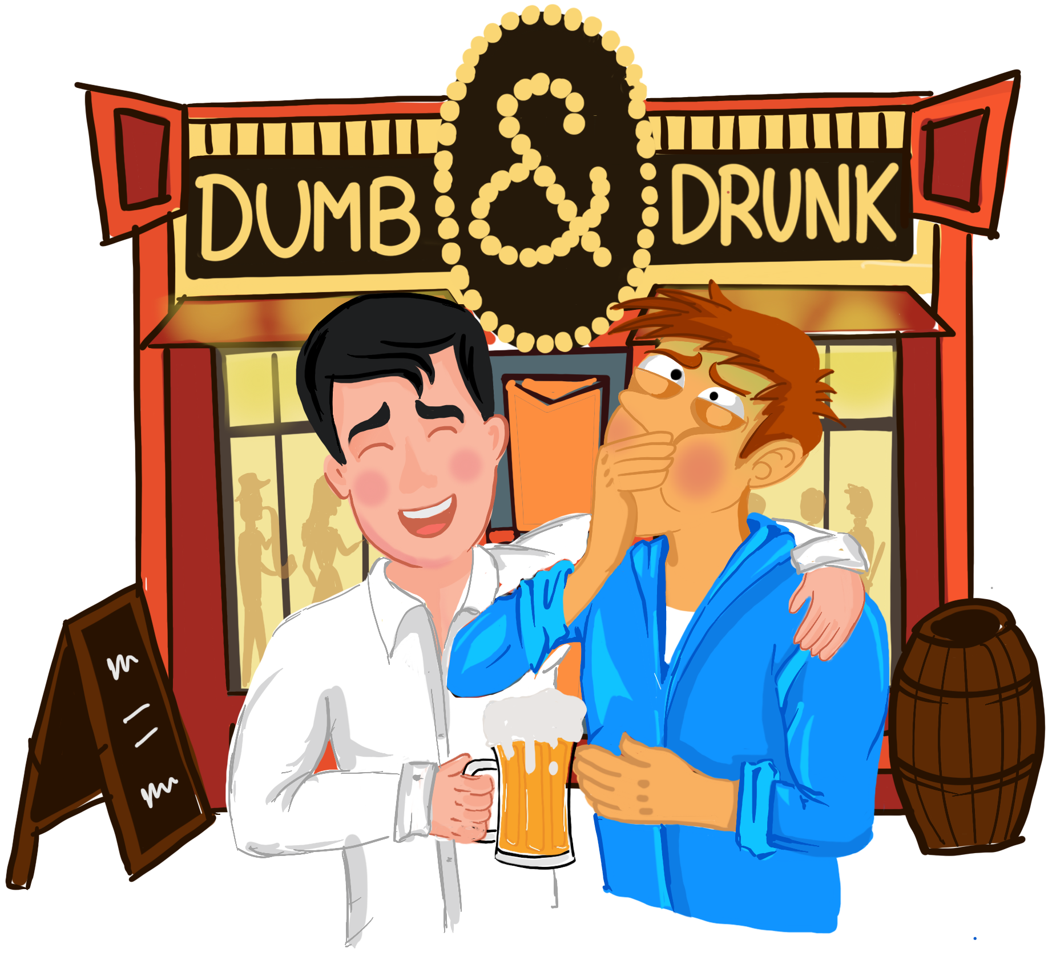

Team Composition


Logronio Gabriel –
gabriel.logronio@studenti.unimi.it
Team Leader – Game design, programming


Dey Arnab –
arnab.dey@mail.polimi.it
Programming, AI, GUI


Linguerri Mattia –
mattia.linguerri@studenti.unimi.it
Game design, programming


Moineau Robin –
robin.moineaus@mail.polimi.it
Game design, programming


Giuliano Davide –
davide.giuliano@mail.polimi.it
Designer, 3D modeler


Mainardi Filippo –
filippo.mainardi@hotmail.it
Sound Designer

INDEX

1. Vision Statement

2. Audience, Platform and marketing
2.1 Target audience
2.2 Platform
2.3 Market analysis
2.4 Competitors

3. Legal Analysis

4. Gameplay
4.1 Core gameplay
4.2 Level and Map
4.3 Wireframes
4.4 Flowchart

5. Game characters
5.1 Players
5.2 Obstacles

6. Story

7. The game world

8. Media list

1. Vision Statement

Dumb & Drunk is a funny and idiotic party game. You and a friend have taken a drop too much and now you are both dead drunk. But there’s class tomorrow and you have to get to bed before falling completely wasted.

While built on the classic party game trademarks such as multiplayer, fast pace and colorful graphics, the game adds new features to make it more compiling:
- Absurd controls- The players are completely drunk and confused, and the game controls reflect it: they are pretty simple yet really hard to pull of. Each button controls a single player limb independently one form the other, rotate the arm, push things aside, stretch a leg to make a step. Moreover they change at the beginning of every game and during a game too, making it impossible to train any muscular memory.
- Funny obstacles- Plenty of procedurally created obstacles will slow you down, on purpose or not, making the epic journey back home even harder and never boring. Will you be able to dodge them?
- Keep an eye on the bars- Two bars show your current status: the balance bar will warn you if you are about to fall: lean on something or try to get your balance again, the nausea bar will tell you how wasted you are: walk steady and take a breath here and there.
- Unique environments- Play in different cities, extremely stereotyped and each with their unique environment and obstacles, a mime will try to slow you down in Paris, a street performer dressed as the Statue of Liberty will bother you in New York and more!
- Cooperate (or not?)- The players must help each other to get to your building gate as you and your friend have a key and both of them are required to open the gate, but then fight for the only bed so you don’t have to sleep on the hard and cold floor.
- Artistic view- Cartoonic style graphic: big heads and short limbs, colorful textures and funny graphic effects take the players in the right mood to have fun, psychedelic and fast paced music with hilarious audio effects will make the game even funnier!

Dumb & Drunk is a funny and hilarious yet frustrating party game that will keep you and your friends glued to the screen, game after game, each with different environments and obstacles!

I’m not “drunk”! You are drunkleyf;gà…

2. Audience, Platform and marketing

2.1 Target audience

According to the Bartle taxonomy players can be divided in 4 types:
- Killers
- Achievers
- Socializers
- Explorers

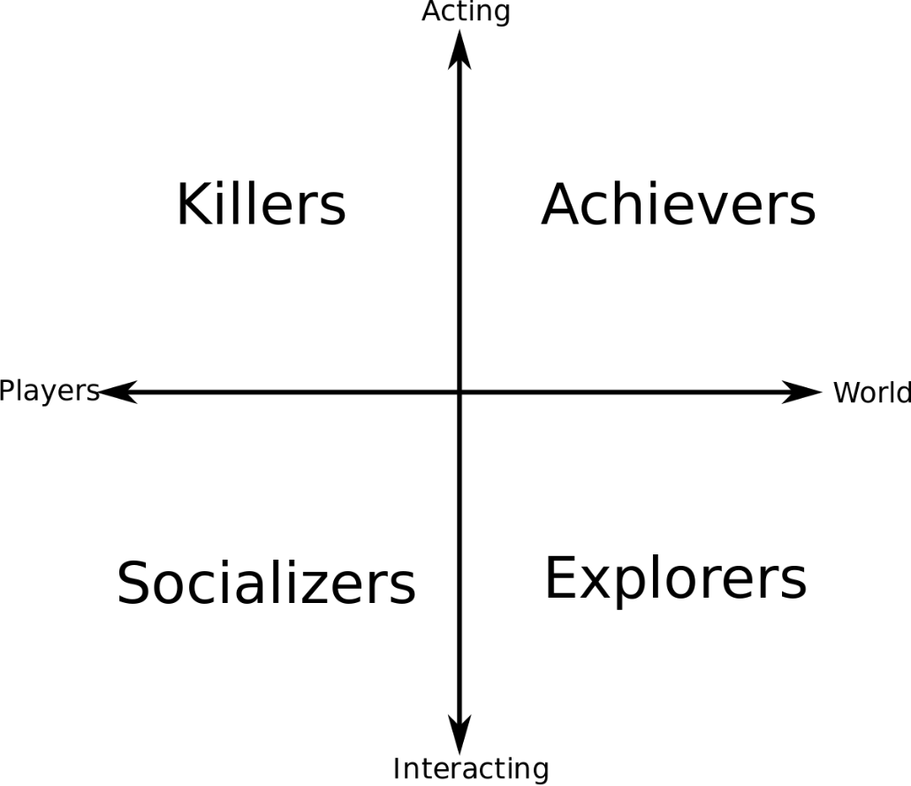

Our game is a party game. Party games purpose is to be used as an icebreaker in certain situations, facilitate interaction and provide entertainment and recreation. The goal of our game is to make friends play and have fun together, so we can say that a Bartle’s type socializer player will enjoy the game more than others.
However Dumb & Drunk is a party game, so the Bartle taxonomy isn’t perfect for this type of games, the real entertainment is given by the type of relation of the players playing together, so really every player can enjoy it if it’s played with the right mates.

This game do not contain either violence or sexual references yet it contains bad language and alcohol making the game not suitable for younger players but instead from young adults onward, but with no distinction between genders.
The game is set to release in Europe, North America and Asia. Being a game with alcohol references it might be banned is those countries in which alcohol prohibition is enforced, but because those countries are not the focus areas of our market it shouldn’t cause major sale loss.

2.1.1 Personas


Name: Trevor
Age: 30
Location: New York City, US
Job: office worker

He doesn’t like videogames very much, he prefers to stay outside in his free time playing basketball with his friends. He plays videogames sometimes with his friends when they just want to relax and have fun together.


Name: Christoph
Age: 22
Location: Frankfurt, Germany
Job: student

He loves videogames and he spend a lot of his free time on them, playing with his friends or alone. When he meets his friends in the evening they like to play party games together for having fun one of another. He also plays with his little brothers, trying to make him enjoy videogames too.

2.2 Platform
The game is set to release on consoles and PCs, but for the last one a compatible game controller is needed. The focus should be on consoles as they allow local multiplayer with many players and controllers, while on PC multiple controllers might not be supported.

System requirements: on console no requirement is needed, on PC the game should run smoothly even on low end systems if well optimized. The basic requirements for running a Unity game on desktop are:
OS: Windows 7 SP1+, macOS 10.11+, Ubuntu 12.04+, SteamOS+.
CPU: SSE2 instruction set support.
Graphics card with DX10 (shader model 4.0) capabilities.

2.3 Market analysis
Top performers: analyzing the “party game” in the home consoles and PCs market the series with the most sales are:
Wii series (201,8 million) with highest sales for Wii Sports (rd: Dec, 2006, sales: 115.12 million);
Mario Party (39,6 million) with highest sales for Mario Party 8 (rd: May 2007, sales: 8,3 million);
Just dance (59 million) with highest sales for Just Dance 3 (rd: Oct, 2011, sales: 10,4 million);

The age target of our game is much more restricted as seen before, and as many children and pre-teens are not suitable for the game the sales are much lower.
As saw in the release dates of the highest sailing games the part games genre market is currently pretty low, mostly for the lack of new game ideas and uniqueness, that’s the reason we target this game genre hoping to bring a new game that can liven the market.
All these games have been released solely on consoles, therefore the PC market has not been explored yet.

Features comparison: while maintaining the simple controls typical of the genre, the hard combination and coordination of them make it different from the rest of the games. The target audience is also really different, not targeting children and pre-teens but more young adults and adults

Sales expectations: 10.000/15.000 copies.

2.4 Competitors

Wii series

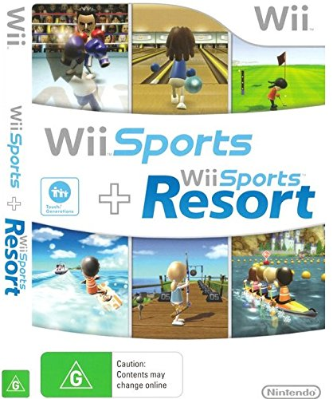

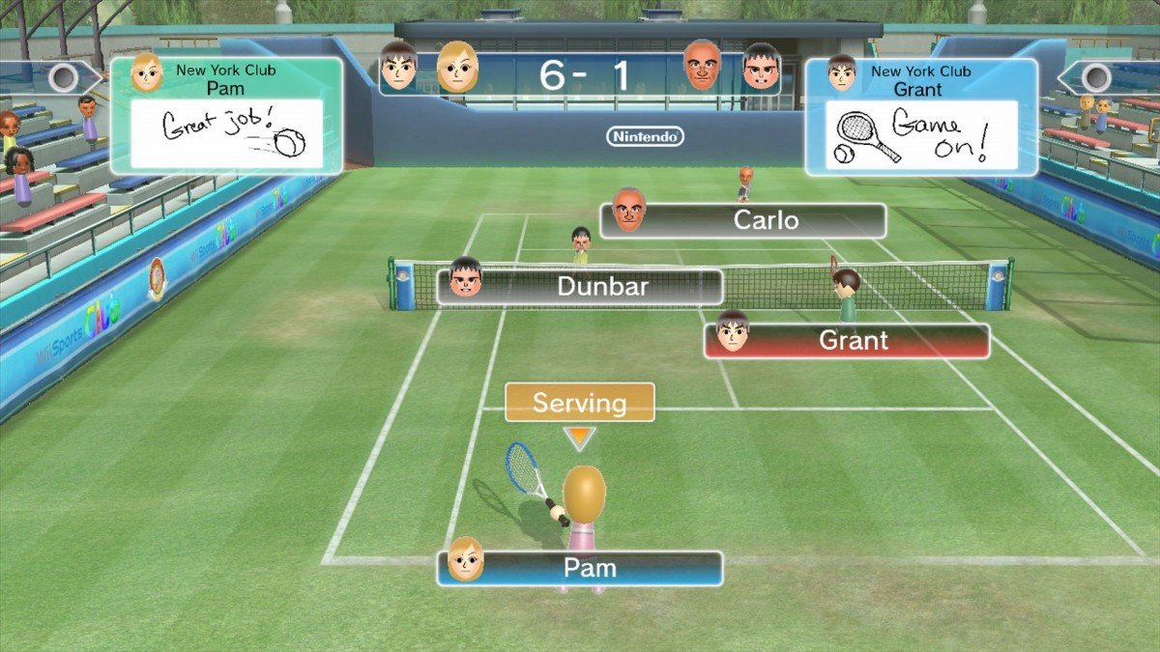

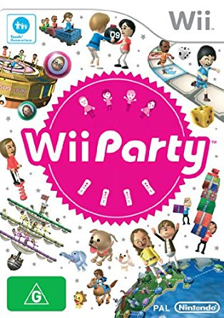

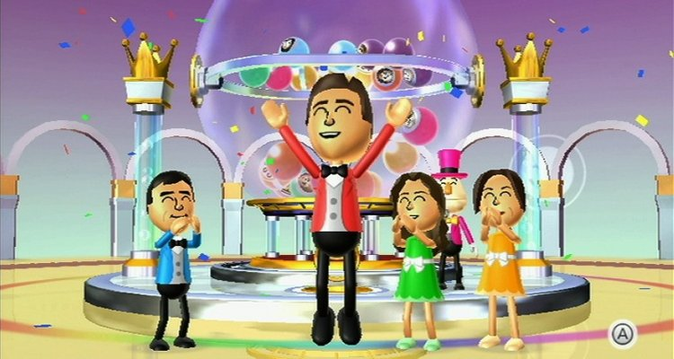

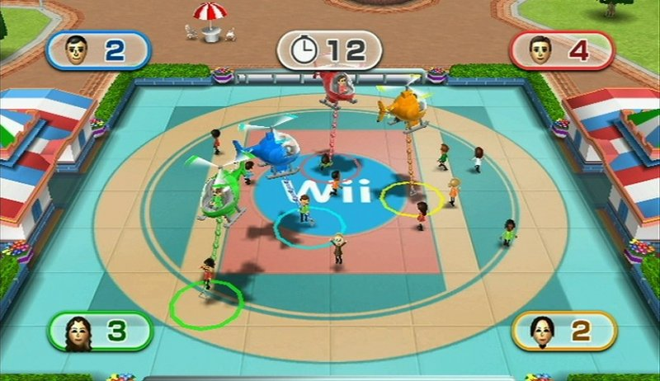

The Wii series is a series of exergaming simulation games for the Wii and Wii U video game consoles published by Nintendo. The series features control schemes that simulate real-life activities with various combinations of the Wii Remote, the Wii U GamePad, and the Wii Balance Board.

Mario Party series

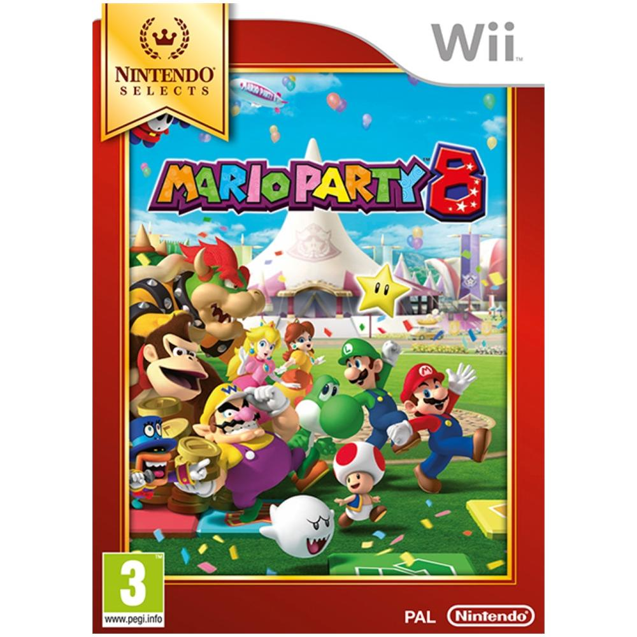

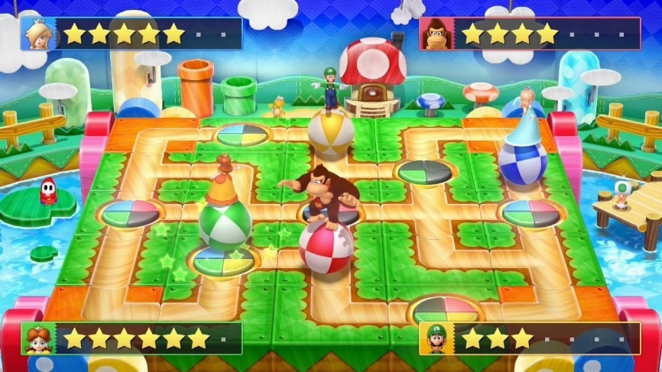

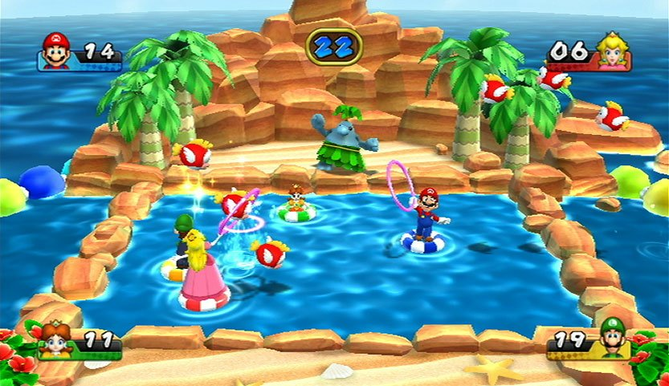

Mario Party is a party video game series featuring characters from the Mario franchise in which up to four local players or computer-controlled characters compete in a board game interspersed with minigames. The series is known for its party game elements, including the often unpredictable multiplayer modes that allow play with up to four, and sometimes eight, human players or CPUs.

Just Dance series

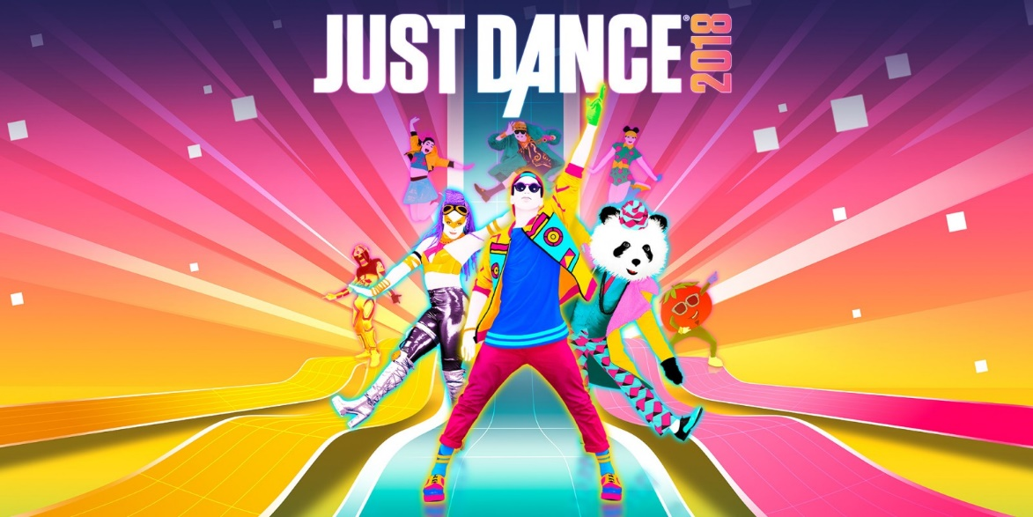

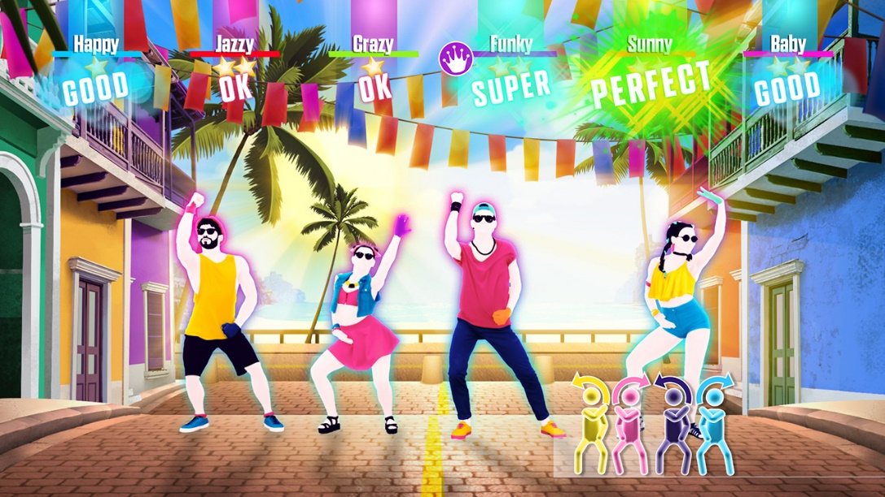

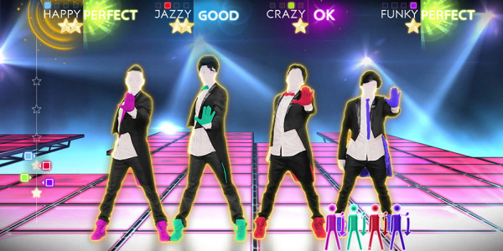

Just Dance is a rhythm game series developed and published by Ubisoft.
It’s a motion-based dancing game for multiple players, with each game featuring a collection of songs each with their own dance choreographies. During each song, players mirror a dance performed by actors on the screen, following commands that appear on the screen, and are awarded for their accuracy.

3. Legal Analysis

The game title is original and therefore free from copyrights, however the title can be shorten into “D&D” which is copyrighted.
The assets used for the characters are mostly made by the graphic designer of the team, while some could be made using Fuse (Mixamo’s version from Steam) and others downloaded from the site Turbosquid and used within the licenses (the models are not directly redistribuited).
The music and sounds are made by the sound designer of the team so both are completely original.

We used the following external softwares:
- Unity Personal 2018.2.14f1, the project is made for a university course and the group doesn’t currently make more than 100k dollars in annual gross revenues, so Unity Plus/Pro are not needed.
- Blender, an opens source released under the GNU General Public License
- Wwise Starter, the production budget is less than 150k dollars and the sound assets are less in number than 500
- Mixamo’s Fuse, from August 22nd 2017 Mixamo’s Fuse is no longer supported as acquired by Adobe (Adobe Fuse CC) but the Adobe’s version lacks many contents that are in the Mixamo’s version.

4. Gameplay

4.1 Core Gameplay
The game is a 2 players physics-based couch-coop and PvP party game about two friends who have to get back home in time but are too drunk to move properly and so will be hard to control.
To spice the things up the street leading back is full of unintentional obstacles that will hinder and slow them down.

Bars
The player state is showed by 2 different bars:

Balance bar


A horizontal bar placed under the feet of each players shows their current balance.
The pointer on the bar starts in the middle and the player has to try to keep it away from the outer parts of the bar: if the pointer reaches either the left or the right red zone the player will fall, losing time while trying to get back up.
The bar swings randomly right or left simulating the unstable balance of a drunk person, moreover moving the player towards a direction will also push the pointer towards that side, i.e. taking a step with the right foot will move the balance towards the opposite side.

Nausea bar

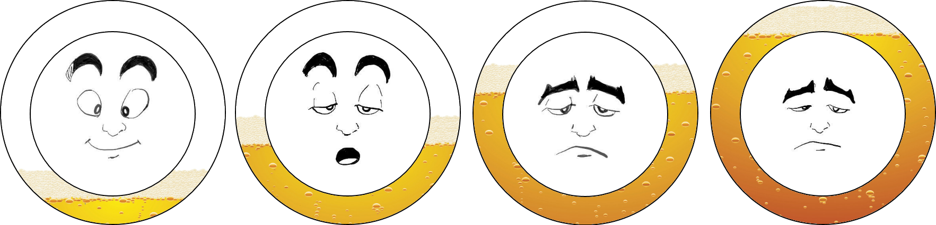
A circular bar around the players icon represents the nausea level of each player. Its value influences the balance bar: the higher the faster the balance bar moves.
This bar fills up while the player moves while it empties when the player stays still, at the cost of losing precious time. There are other ways to empty the bar: picking up food can either fill or empty it, picking up a special power up will make the player throw up and completely empty it.
If the bar fills up completely the player will fall, losing time waiting the bar to empty for a certain amount. A picture of each player shows it’s current status.
The bar influences the graphics and the sounds of the game, distorting the graphic mimicking a drunk person’s vision and weakens the sounds and music in background.

Controls
The controls are semi-randomly selected at the beginning of each match making it useless to try to train a muscle memory.
4 buttons control the player’s movement:
One button controls the right arm
One button controls the left arm
One button controls the right leg
One button controls the left leg

Obstacles
Along the way home the players will meet various NPC depending on the city where the players are in who will try to hinder and slow them down. They are different for each cities and can be divided in: stationary, slow moving and fast moving.

New York
Taxi
[image] | Stationary obstacle, stays parked on the side of the road, if a player touches it the alarms goes of and the players in a given range gets pushed a little away due to the scare and the balance bar swings in the same direction of the push.
Broken Fire Hydrant
[image] | Stationary obstacle, stays on the side of the road, if a player touches it water spills out, forming a puddle around it, making the balance bar swinging much faster for all players on the puddle.
Fast food mascot
[image] | Stationary obstacle, stays on the side of the road rotating a fastfood sign. If a player gets hit by the sign gets pushed away.
Old granny
[image] | Slow moving obstacle, comes out a building and walks slowly in the same direction of the players occupying a whole sidewalk.
Drunk tramp
[image] | Slow moving obstacle, stays on the side of the road until a player gets into range, that follows him standing beside him and making it harder for harder to walk. Leaves the player after getting far enough from the starting distance.
Hot dog cart and seller
[image] | Fast obstacle, comes fast towards the players in the middle of the street, if he hits the player he gets pushed back a lot.

Paris
Box of baguettes
[image] | Stationary obstacle, stays in front of the bakery, if a player hits it, it breaks and spills all the baguette, making the balance bar swinging much faster for all players on the baguettes.
Falling flowerpot
[image] | Stationary obstacle, falls from a balcony, if it hits a player he falls on the ground like if he had lost balance.
Dining people
[image] | Stationary obstacle, stay seated around a table, occupying most of the street. Don’t react to the players.
Street artist playing and a couple dancing
[image] | Slow moving obstacle, the artist plays his instrument on the side of the sidewalk while the couple dances in the middle of it., if a player hits them he gets pushed away a little.
Mime
[image] | Slow moving obstacle, performs on the sidewalk, if a player gets in range the mime starts following him walking by his side and bothering him, after few seconds goes back to his starting point.
Baguette seller on bike
[image] | Fast moving obstacle, comes fast towards the players in the middle of the street, if he hits the player he gets pushed back a lot.

Pick-ups
Throughout the game many items can be found, semi-randomly generated and placed on the map.
- Statistics enhancers
Some items will modify the players characteristics such as movement speed, bars resistances etc.
- Food
Food can either empty or fill the nausea bar depending on whether the food is spoiled or good.
- Pill
Picking up the pill makes the player throw up and completely empty the nausea bar.

4.2 Level and Map
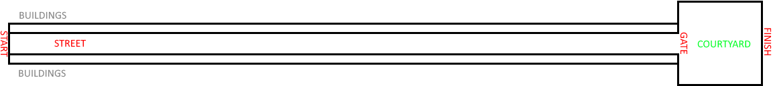
The map consists in a long straight street leading to a gate that allows to enter in the courtyard and therefore the players’ home.
Both the obstacles and the pick-ups are placed through a PCG algorithm in the first part of the map (the long street) while in the courtyard the players will be left alone in 1v1.

4.3 Wireframes
To be added.

4.4 Flowchart
To be added.

5. Game characters

5.1 Players
The players embody two friends that have just got some drinks and are really drunk.
The players has different statistics that make them unique such as: movement speed, bars resistance, length and weight, force etc.
Player 1
Player 2

5.2 Obstacles
The obstacles can be either people or objects.
The people obstacles are:

New York
Drunk tramp: he thinks to be a war veteran but it’s just because of his alcoholic habits. If you ask him he fought in Korea and Middle-East and on weekends he adds the civil war too.
Old granny: what is she doing around at you might wonder: well she doesn’t know either. But she will do it extremely slowly.
Hot dog cart and seller: with so much drunk people around this cart makes big money. What a disgrace to take advantage of these people… yes just ketchup please, no veggies.
Fast food mascot: dressed as a mayonnaise bottle, he spins his sign attracting people towards the fast food. Let’s pretend that the yellow stain between his legs is mayonnaise.

Paris
Dining people: talking, laughing and chewing as loud as possible… Well at least they are not taking pictures of their food.
Street artist playing and a couple dancing: oh so romantic! If only he wasn’t doing the floss and he wasn’t doing the hype dance…
Mime: he is either well known mime all around the world or he thinks to be a fish that has just been taken out of water. I don’t know, I’m not good in charades.
Baguette seller on bike: with his classic beret and mustaches, he brings baguette to the people. No jokes on croissants, he wants to keep his head on his shoulders.

6. Story

The players take the roles of two college students, friends and room mates. After a meeting again after the holidays they decide to go out and have a drink together, and another drink… and another one… they LOTS of drinks together and now they are dead drunk.
But they remember that classes start the following day and they can’t miss it to make a good impression on the professor.
They get out the bar and start walking back home. Luckily the road is all straight and they can’t get lost. Just put one step in front of the other and they slowly walk their way back home, but it seems the world is against them.
Gina, the old lady of the flower shop, is walking slowly on the sidewalk, preventing them from going over her, this will take an eternity! As they decide to cross the road a car passes fast on the road, just few centimeters from them. Lucky for not to long: a cat sees and charges them. The jerk… I mean the cat wants to make them fall at all costs but a passing dog makes it run away.
After all the obstacles the two friends reach their home gate leading to the building courtyard, but as they enter they remember that just one of the bed is usable: they rush towards it as the first one to enter the room will get to sleep on the bed, while the other will have to sleep on the floor. Who will arrive first?

Backstory: one of the two friends has passed the holidays back in his hometown and had just comeback right before the start of the semester. They then decide to go out to celebrate before setting up the rooms, they will later find out that is was a huge mistake!

Narrative devices: the story is explained in a short cinematic before the loading screen. It can be also deduced by the random dialogues between the two main characters during the game.

7. The game world

The game can be set in various cities all around the world, each of them with their uniqueness in environment and obstacles.

The map is similar in all of them: a long street with two sidewalks and a narrow single lane road, towered by a lot of buildings all similar to each other and a series of lamps that light the street. It’s full of obstacles and leads to the main gate of the building where the characters live in, it leads to a small courtyard in which the players have to walk for a little before finally arriving at the room door which represents the end of the game. Exact sizes will be added after a set of prototypes.

A small minimap shows the current position of the players along the street and manage the remaining time, the minimap disappears as soon as they enter to courtyard as the time stops and the players rush to the door.

The game takes place at night, the sky is clear without a cloud as the moon light shines and projects long shadows on the street.

8. Media list

The game requires 3D Assets for:
2 Players: the model must be divided in different parts, each moving independently.
NPCs obstacles both human (granny, group of students etc) and objects (car, boxes, vases etc);
Environment: long street with buildings, lamps, trash cans, etc.
The game requires animations for:
NPCs and moving objects, while the main characters will need minimal animations as they will be guided by the players.
The game requires sound effects to enhance the immersion in the game and a background music keeps the player active.

9. Technical spec

The game has been developed using the Unity game engine, because it had already been used by most of the team members and it has been taught during the course lessons.
The sounds database is created with Wwise and integrated into Unity using its own plug-in.
The game characters have been created using Mixamo Fuse, modified using Blender in order to make them more suited to the game style and mood before getting imported into Unity.
The game environment and 3D objects are modeled using Blender and imported in Unity.

The game is meant to be run on either home console or PC (an external game controller is suggested, using a keyboard is still supported but not recommended) in order to play in multiplayer on the same screen.

The game is initially for 2 players in couch-coop / PvP mode playing on the same screen, further in the development a 2v2 mode could be implemented, 2 players in co-op racing against other 2 players.

The game will be initially played on just one device and no network is needed, further in the development a 2v2 mode could be implemented making it needed the development of a local network for gaming on PC.

Design History

Date | Update | Responsible
31-10-2018 | Creation of the document, first sections. | Logronio Gabriel
01-11-2018 | Detailed Gameplay | Logronio Gabriel
2-11-2018 | Technical Spec | Logronio Gabriel
8-11-2018 | Detailed target audience and market analysis | Linguerri Mattia
10-11-2018 | Detailed obstacles | Logronio Gabriel
11-11-2018 | Added UI images | Logronio Gabriel

